Template for Departmental Activity Report

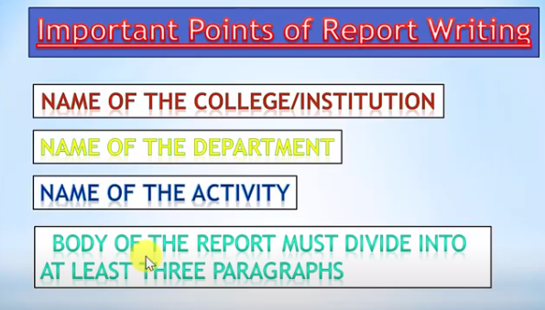
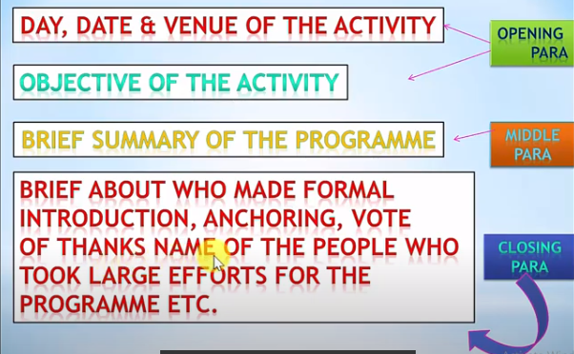
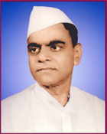
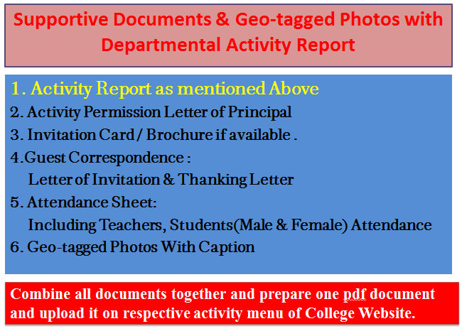
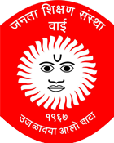
Janata Shikshan Sanstha’s
Kisan Veer Mahavidyalaya,Wai
Department of N. C. C.
Republic Day
Report
The “Republic Day” was organized by the department of NCC on 26-01-2020 at Janata Shikshan Sanstha’s ground. Dr. J. S. Choudhari, Secretary, Janata ShikshanSanstha, Wai was the Chief Guest of the programme. The flag hosting was celebrated at the hands of Dr. J. S. Choudhari. The Principal welcomed Dr. J. S. Choudhari in his address, threw lights on the lives of martyrs. He also narrated the progress of India.
The same ceremony was celebrated at Kisan Veer College, Wai at the hands of the Principal Dr. C. G. Yeole. He delivered speech on various issues our country is facing. Lieutenant Sameer Pawar anchored the program. 200 Teaching & Non Teaching staff, 105 NCC cadets, 150 students attended the program.

College Seal
Dr. I. F. Pailwan Lieutenant Sameer Pawar
Principal NCC Officer
Kisan Veer Mahavidyalay,Wai NCC Unit
2. Activity Permission Letter of Principal

Paste the PDF

4. 4.Guest Correspondence:
Letter of Invitation & Thanking Letter

Paste the PDF
3. Invitation Card / Brochure if available

Paste the PDF

Combine all documents together and prepare one pdf document and upload it on respective activity menu of College Website.
Caption
Caption
Paste the PDF
Paste the PDF
Caption
Caption
Paste the PDF
Paste the PDF
5. Geo-tagged Photos With Caption

Paste the PDF
5. Attendance Sheet:
Including Teachers, Students
(Male & Female) Attendance

